Open current SM00 Tracking Report: (current one is located as of September 2023)

G:\Clerical\Seg Dept\SM00 REPORTING

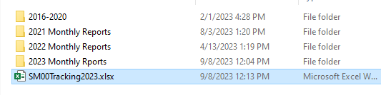

1. You will be sending **two** different PDF files/reports: Regular SM00 & Description Changes, they are both located in these two tabs

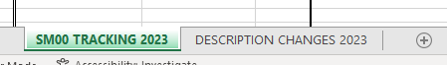

1. We only send what was done and Audited by your teammate. // if no initial under AUDIT column **DO NOT INCLUDE IN THE REPORT. This report is sent on 5th of each month.**
2. **To stay organized in the spreadsheet: (you will see 3 different colors)**

**GRAY** – previous SM00 reports

**ORANGE** – SM00’s that were sent last month

**BLACK** – current SM00’s that haven’t been sent yet // they also don’t have a name of the “MONTH” in the “SUPP GROUPS SM00 Month Sent” Column, that’s how you can identify what needs to go on this months report.

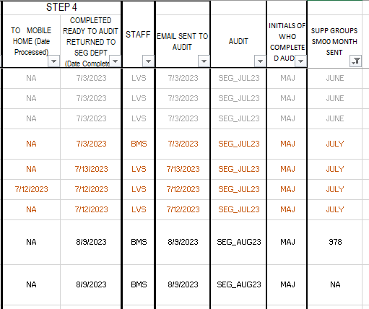

This will be changed to which “MONTH” they will be send on the report.

SM00’s that were sent LAST month marked in **ORANGE** // This will be changed to **GREY** by person who is generating the report.

*NOTE:* While SEG is working on current SM00’s they will keep Notes in here, which Supp Group the SM00 is placed in. Once its Audited, and ready to be sent on the report, in this column YOU will change to the MONTH.

1. Copy PREVIOUS SM00 report Excel Sheet – so that the format can stay consistent. (don’t fix what is not broken😊)
2. This is how they should be named:

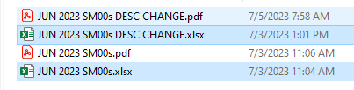.

1. Change the HEADER to SAY what month SM00’s were done in:

//if the SM00’s are done in AUG the report is sent in SEPTEMBER  
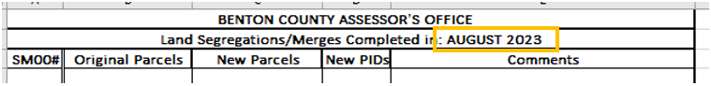

1. Copy ALL “READY TO GO” SM00’s from SM00 TRACKING spreadsheet (highlighting on the edge of the spreadsheet)

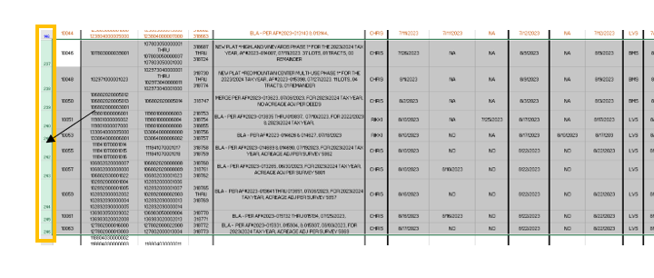

1. PASTE and clean up the spreadsheet to look like previous report

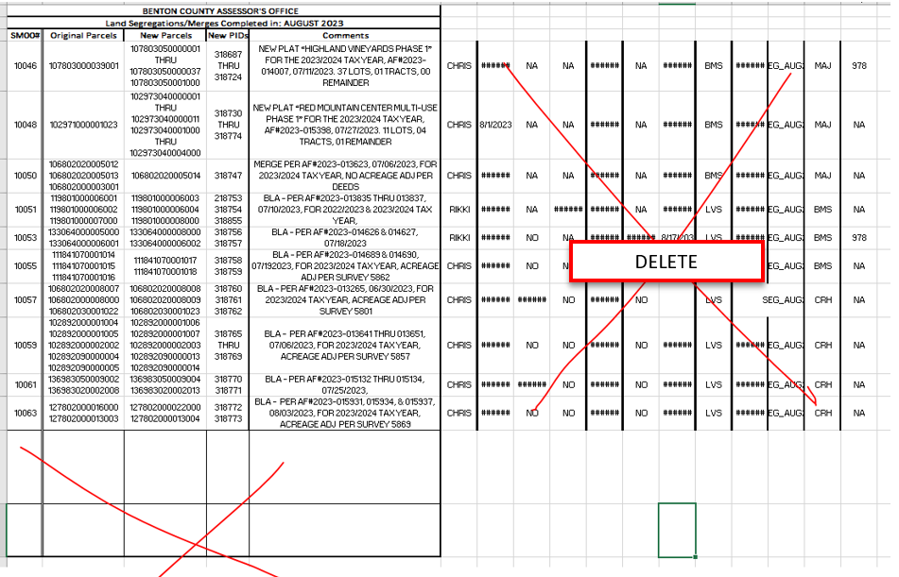

**TIPS for cleaning up report:**

1. Expand all rows/columns to make sure all info is being shown, sometimes info can be cut off.

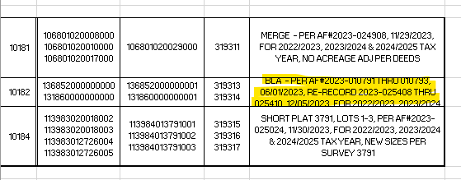

**TIPS for Formatting:**

1. Select the TABLE with all the SM00’s 2. Select ALL the SM00’s again

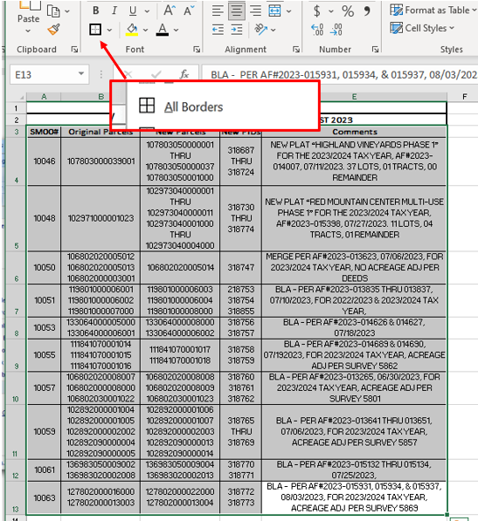 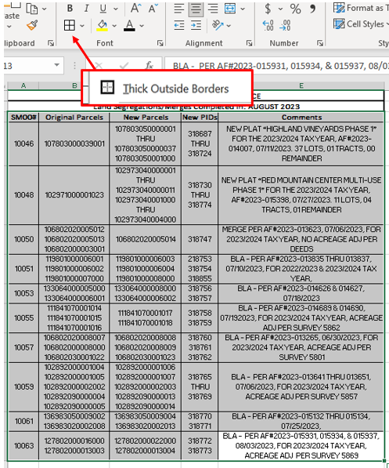

Sample of the report.

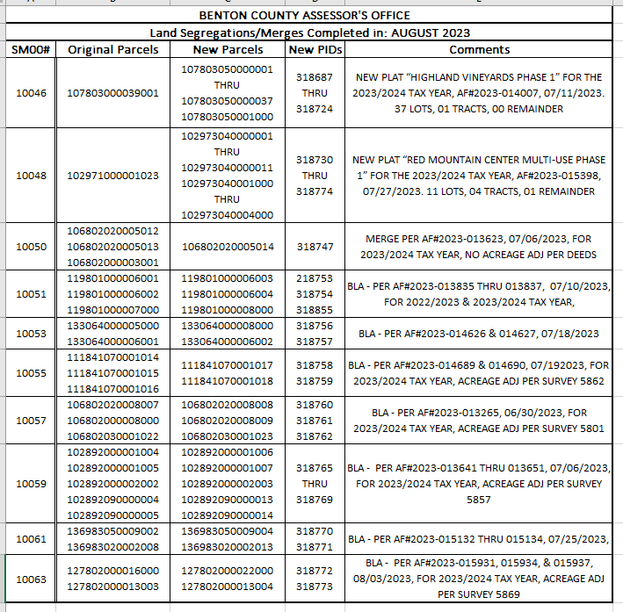

1. **Select/highlight the entire bordered SM00 report.**

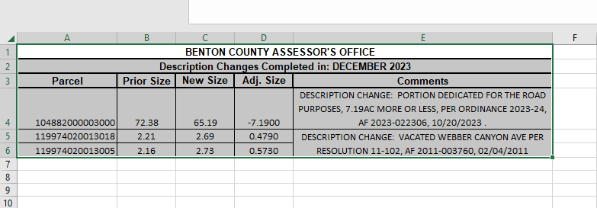

1. **Print to PDF & under “Setting” change to “Print Selection:**

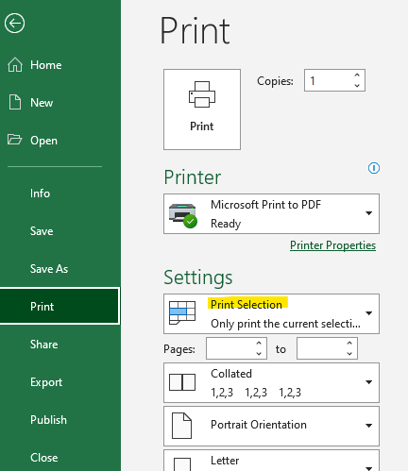

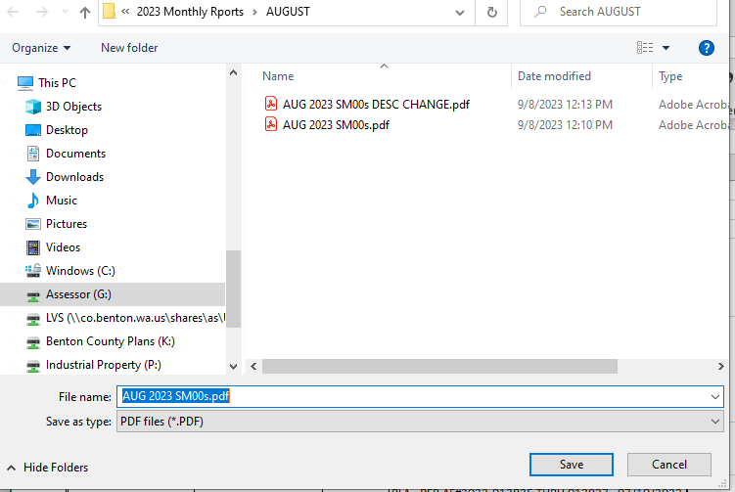

1. Sending Email.

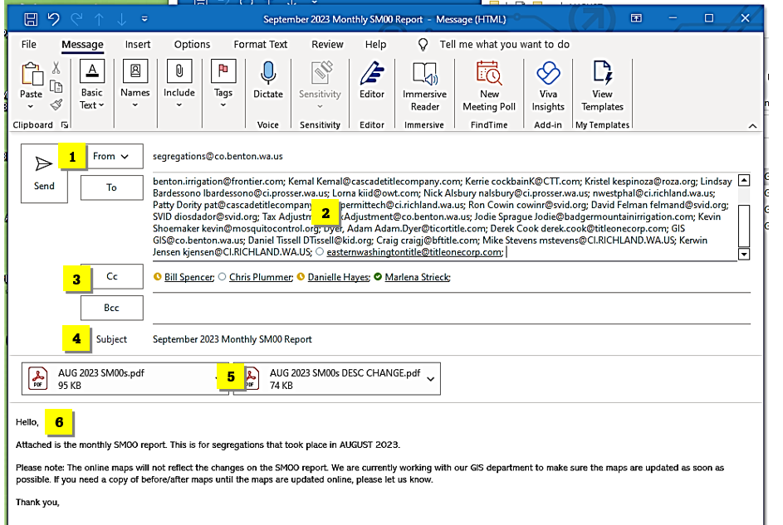

1. FROM: Always send from [segregations@co.benton.wa.us](mailto:segregations@co.benton.wa.us) email.
2. TO: you can find this list in the seg email:

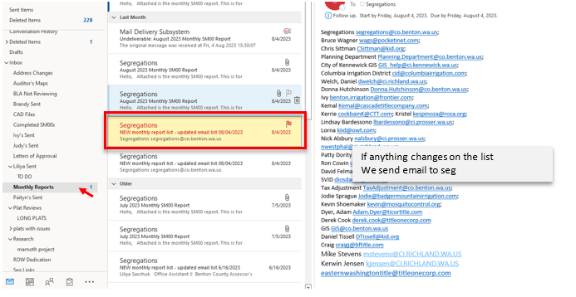

1. CC: Bill Spencer <Bill.Spencer@co.benton.wa.us>; Chris Plummer <Chris.Plummer@co.benton.wa.us>; Danielle Hayes <Danielle.Hayes@co.benton.wa.us>; Marlena Strieck [Marlena.Strieck@co.benton.wa.us](mailto:Marlena.Strieck@co.benton.wa.us)
2. [September] 2023 Monthly SM00 Report // change September to what is the current month.
3. Attached PDF files
4. Body: **change the month***

Hello,

Attached is the monthly SM00 report. This is for segregations that took place in [**AUGUST**] 2023.

Please note: The online maps will not reflect the changes on the SM00 report. We are currently working with our GIS department to make sure the maps are updated as soon as possible. If you need a copy of before/after maps until the maps are updated online, please let us know.

Thank you,

[your signature]